**Experiment No :** 05

**Experiment name :** write a C program for bubble sort (Ascending or Descending order )

**Methodology :**

1. Take the input for the size and elements of both matrices from the user.
2. Check if the dimensions of both matrices are compatible for addition (i.e., they have the same number of rows and columns).
3. Perform the addition operation and store the result in another matrix.
4. Display the resulting matrix after addintion.

**Flow-Chart :**

string1[i] != string1

yes no

char string1[100]; int i, length ; int flag = 0 ;]

Input word

scanf("%s",string1);

**Code :**

Print: not palindorm

Print : palindrom

Flag = 0;

Flag = 1 ;

for(i=0 ; i<length ; i++)

length = strlen(string1);

#include<stdio.h>

int main()

{

int array[100] , num , c , d , swap ;

printf("Enter number of elements : ");

scanf("%d",&num);

printf("Enter %d integers\n",num);

for(c=0 ; c<num ; c++){

scanf("%d",&array[c]);

}

for(c=0; c<(num-1) ;c++){

for(d=0;d<num-c-1 ; d++){

if(array[d] > array[d+1]){

swap = array[d];

array[d] = array[d+1];

array[d+1] = swap ;

}

}

}

printf("Shorted list in ascending order :\n");

for(c=0 ; c<num; c++){

printf("%d\n",array[c]);

}

printf("\nSorterd list in descending order:\n");

for(c=num-1 ; c>=0 ; c--){

printf("%d\n",array[c]);

}

return 0;

}

**Output:**

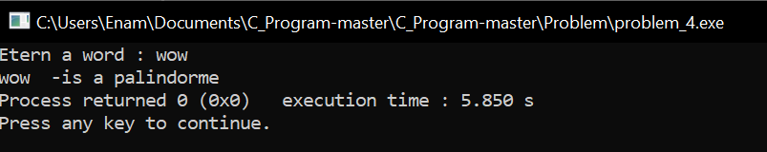

**Result discussion :**

In this matrix we take the column and row of the best matrix from the user, then the elements of the first matrix are taken from the user, then the elements of the second matrix are again taken from the user, this time the two matrices are added and the output is shown to the user.